**Part I: Interview**

time:

4 minutes

Teacher:

*In the first part of this test, I am going to ask each of you some questions.*

*In the interview,* ***I will ask each of you*** *each* ***question*** *in the following way:  
A, then B , then C /C, then B, then A / B, then C, then A.*

*We will start when you are ready.*

* What can you tell me about yourself and your family?
* Do you like going to school / why / why not?
* If you could, what would you change about your school?
* If you could take part in one the exchange programmes at our school – where would you like to go: to the UK, the USA, France, Brasil or Russia?
* Do you like watching TV, Netflix or surfing on the internet?
* Do you have any favourite actors, you-tubers or pop-stars?

*This is the end of this task.*

**Part II: Monologue A**

Teacher:

*Now I'd like each of you to* ***talk about pictures****. You have about* ***2 minutes each****.*

**Candidate A***: You will start. Here is your material.*

time:

2 minutes

* Describe one of the pictures.
* How might the people in the picture feel and why?
* Do you like spending time outdoors / in the open countryside? If not, what would you rather do?

*Shall I repeat the instructions?*

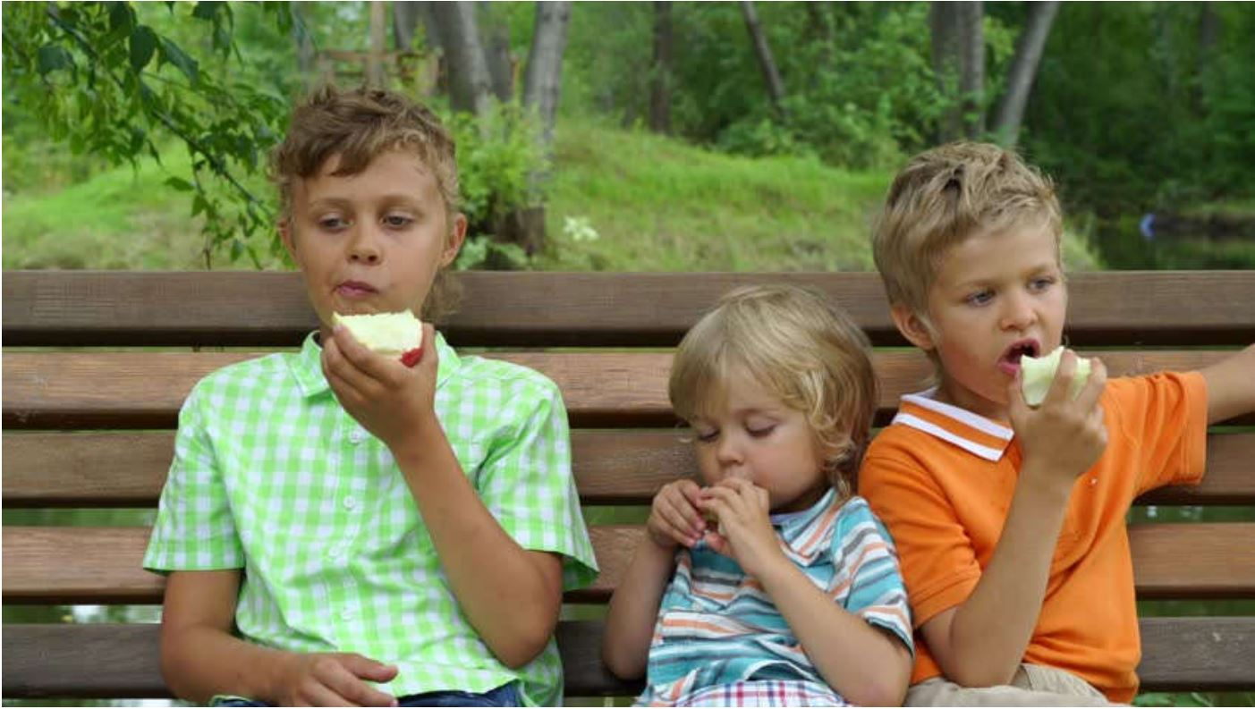

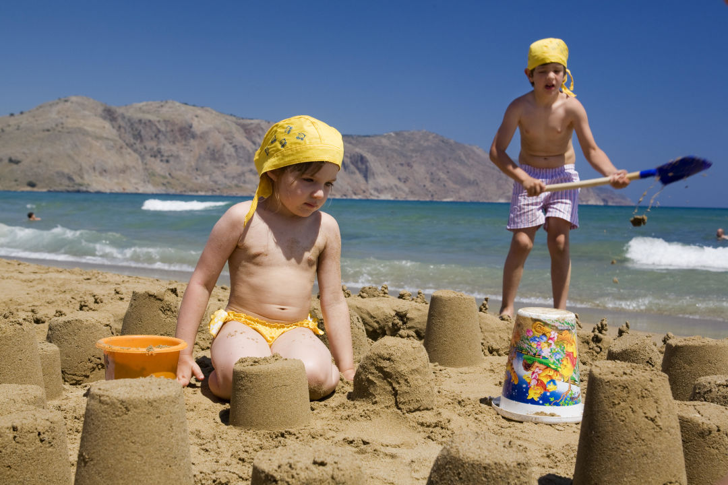

**Candidate B***: Now it's your turn. Here is your material.*

time:

2 minutes

* Describe one of the pictures.
* How might the people in the picture feel and why?
* What kind of activities do you like to do, and with whom do you like to do them?

*Shall I repeat the instructions?*





**Candidate C***: Now it's your turn. Here is your material.*

time:

2 minutes

* Describe one of the pictures.
* How might the people in the picture feel and why?
* What kind of games do you like to play? What else do you like doing  
  in your free time?

*Shall I repeat the instructions?*

**

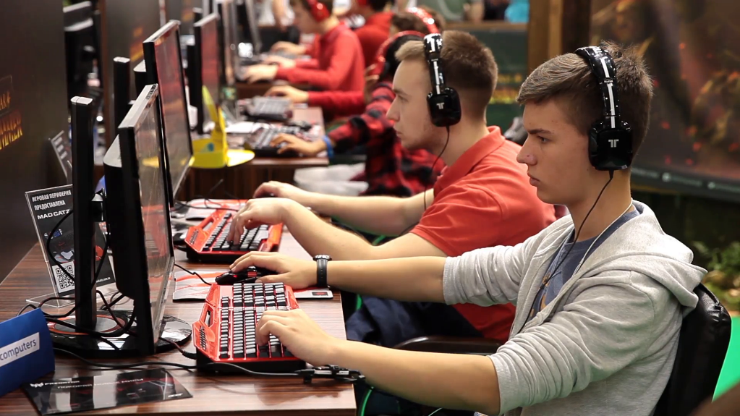

**Part III: Paired Discussion**

time:

4 minutes

Teacher:

*Now I'd like each of you to* ***talk to each other****.*

I’m going to describe a situation to you.

One of your teachers is in hospital after a car accident. You are going to buy a present for him.

Here is a picture with some ideas. Talk about the items in the picture. Discuss what your teacher might enjoy**.** If you have any more ideas, tell your friends about them.Then agree on the present you want to buy.

